Testing one |  | Process Instructions:  Batch Subrogation Claims Submissions
Revision Date: 5/12/2022 | Next Review Date:  5/12/2023 | CTO Functional:  Subrogation (Electronic)
Purpose | The purpose of this work guide is to provide instruction on processing production batch subrogation claims for Commercial, Medicaid, Medicare, and LINET lines of business. The other payers, specifically Medicaid agencies, other health plans or third party agencies submit subrogation claims (ECT Subrogation batch files) directly to Humana for processing through the RxbatchClaims@humana.com mailbox. These files may require a formatting change to allow for processing.
Definitions | Subro  ECT | A subrogation transaction is the transmission of a claim from a Medicaid agency to a payer for the purpose of seeking reimbursement from the responsible health plan for a pharmacy claim the State has paid on behalf of a Medicaid recipient  Electronic Claims Transmission, also known as Batch Claims. While either term is used to refer to Electronic Subrogation files, it is not only used for Subrogation.

Procedure | - Responsibilities:  - HPS Claims Operations is responsible for:  - Ensuring timely submission of Other Payers Subrogation Batch Claims Files upon receipt.  - Receive, process and return batch file responses to the other payers who submit directly through Humana.  - Humana Production Control completes the mainframe request for reformatting files into the appropriate NCPDP format for processing and initiating the NDM to send formatted files to SS&C  - SS&C processes batch files and returns response files.  - Frequency and Time Period:  - Batch claims submissions are received via the RxBatchClaims@humana.com inbox from other payers.  - Batch files are received intermittently from various other payers.  - Process:  - Review the file/s submitted for additional action necessary to prepare the file for processing.  - Puerto Rico – not part of Change but processed the same way. Password: COB2022 (year file received in) Follow same process below, but will need to create a new spreadsheet adding SUBMITTED and the number of claims to the naming convention using the BATCH CLAIMS TEMPLATE in MMM Healthcare – PR folder. Move data to appropriate columns from original sheet.  - Drag File in to the Agency file  - Open file and label first tab Raw Data, check last column of data and if Qty2 column is listed, remove the column. Also if column does not have data in row 1, delete column or if know the heading add it (i.e. LOB)  - Open ‘Adding Quotes and commas for IN statements in SQL’ spreadsheet from shared folder  - Copy H numbers and paste into ‘Adding Quotes and Commas’ spreadsheet starting in column A2. In column B1 double click square in lower right corner to populate H numbers all the way down with the quotes and commas.  - Medica, BCBS MN, and various Centene entities (all submitted by Change Healthcare) will require dividing the file by customer number as each customer needs to be submitted as a separate batch. Use the SQL query linked below to pull member data – the linked Excel file can be used to add the necessary commas and quotes for the query. Create a copy of the submitted file in a new tab then use V-look up between the query results and submitted file to add a customer number column. Then create a new tab for each customer and divide the submission data by customer into each of those new tabs, removing the customer column when complete. .  - Open CHANGE HEALTHCARE\CUSTOMER LOOK UP FROM H-Number.sql–This will open the SQL.  - Open PLSQL, click on New  - Paste SQL from customer lookup notepad  - Copy ID’s from ‘Adding quotes and commas’ in column B (starting with row 2).  - Paste ID’s after last parentheses in SQL  - Go to end and delete comma and add end parentheses.  - Click on blue arrow to the right choose excel file.  - Dedup the raw data tab for running this query to identify multi customer #’s on one member  - Save using original file name and add mbr_lookup to the beginning of the file name. Save in the Agency folder  - Open member_lookup spreadsheet  - Click on customer # in cell 2B (make sure you get yellow triangle with exclamation point) then highlight all the way down  - Click on yellow triangle and choose convert to number and change to from General to Number in menu  - Remove the decimals by clicking on the right blue arrow under number and save spreadsheet.  - Go to Raw Data spreadsheet make sure col A is number, insert col next to col A.  - V look up using original (raw data) and member file (with customer).  - Click in B2 cell, fx (insert function) and choose Vlookup  - Lookup value = A2 (click in cell and it will populate), Table_array = highlight column A and B on member lookup, Col index = 2 and range lookup = 0, click ok, the customer # should be populated on 2nd line.  - Double click on the right lower corner (tiny square) of cell B2 where customer # is populated and additional cells will be populated with the customer number  - Remove decimal and zeros in column b.  - Add Filter and filter by customer number and copy (need to highlight each cell not copy page) each list of customer #’s into individual tabs. (N/A normally is 319. If H number it can be different cust #. Check under RX Nova and get regular member ID if 319. Update customer # on spreadsheet. Only change ID to number if 319. You can run a query for N/A in RX Intel, Alt ID needs to be 18 digits, add zeros in front of ID number.)  - Rename Tab with Customer number. Remove Column B with Customer # on Individual tab. Save updates.  - For file to be successful through WILD, ensure the following (use formula =LEN(A3) to find # of characters, includes spaces)  - ID max length is 11  - No spaces or characters in a cell  - Birthdate format 01/01/2022  - First Name max length 12  - Last Name max length 15  - Rawlings - Use the same process as above to determine customer.  - Each of these Other Payers have been assigned a specific access database for file formatting. Format the file using the appropriate Access database located in one of the folders in the batch files folder (\\Rsc.humad.com\qdrive\Pharmacy Other\Pharmacy COB\Batch Files). The data should be imported and formatted 1 tab at a time since each tab is representative of a different customer and/or member ID type. Once you access the appropriate database, follow these steps:  - Delete the old data - Button for performing this function should be on the main menu  - Import the raw data from the excel spreadsheet into the database, click the external data tab; click excel, click browse in pop up, choose file you are working on, choose append and “Raw Data” table in the drop down. Import Spreadsheet Wizard pop up: Click on each customer (i.e. 544), next, finish, close.  - Click the “Update Raw Data” button on the main menu and follow the prompts  - You will receive a notice requesting to “Enter 4 digit customer #” – Enter 0544, 0320, 0319; whichever is applicable for this specific batch.  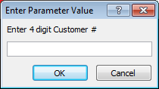  - Next, enter the agency ID from the current Agency ID list:  \\Rsc.humad.com\qdrive\Pharmacy Other\Pharmacy COB\Batch Files\Agency and Agency IDs  - Each ECT subrogation batch file needs to be assigned a batch number.  Batch file naming convention using the julian date plus a two digit extension.  Click the link to navigate to: http://longpelaexpertise.com/toolsJulian.php  The current day’s Julian date will be displayed. For the first batch of a day, use the extension ‘01’ and for each subsequent batch continue counting up with ’02’, ‘03’, etc.  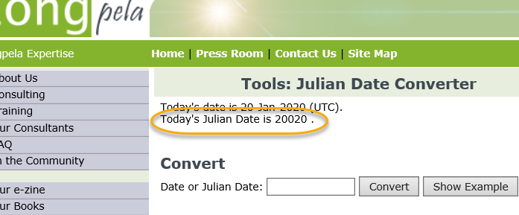  - When prompted, enter the appropriate Vendor Code and Sender ID from the table below:  - Click the “NPI” button – this will upload the 10 digits in the background. Wait for the dialog box and click “ok”.  - Click the “Export Results” button.  - Go to the folder location noted in the prompt and rename the text file (need Julian date) with the batch number given in step 3 above.  - Open batch file and add the number of claims to the bottom of column one and save it and move to Wild Folder on Desktop  - Go back out to the folder where the database is housed in and look to see if there is a file named “Export of Removed Claims” document. Open and review.  - Any claims contained in this document were either past the timely filing limit of 3 years (1,094 days), out of balance (Gross amount not equal to sum of ingredient cost + dispense fee) or a required field in missing. If there are any claims exported, review each row to determine the cause of the claim(s) being removed from the population.  - These claims will need to be sent back to the submitting entity so that they can be notified of the reason it could not be processed.  - If there are no claims, delete the file, a new one will be created with each update of raw data.  - Save a copy (move) of the formatted batch text file in a folder you create either on your desktop or your my documents folder on your local drive.  - Rename the files by their batch ID  - When submitting, rename the file to: edw_prod_subro_batch_file.csv  - Remember if you haven’t added the count, while the file is still in text format to add the row count to the bottom of the file after the last line of data.  - 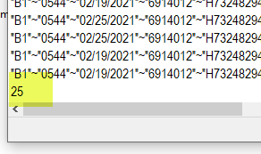  - Click the link to navigate to Workday  - Select Workday & Apps  - Select Humana Self Service (HSS)  - Under Business, click the WILD Application link.  - When WILD opens, change the server name to EDW PROD  - Click Browse and navigate to where you are saving the text files created by the database – THIS MUST BE ON YOUR C DRIVE (Local Drive). The application will not work if you load the files from the shared network drives.  - 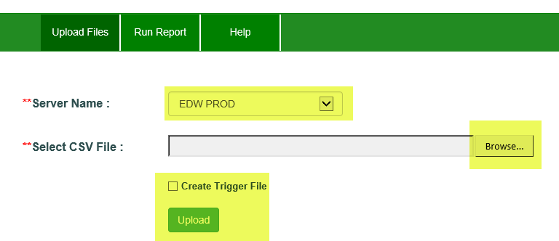  - 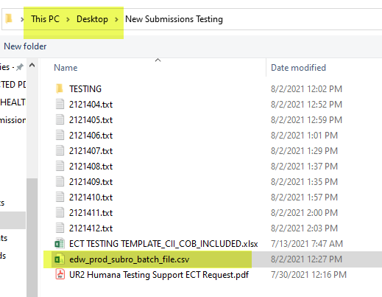  - The file must be named edw_prod_subro_batch_file.csv (It will ask you if you are sure you want to change the document type, click ok)  - Wait for both email to arrive in the RxBatchClaims@Humana.com email box before selecting the next file and repeating the process to run more files. 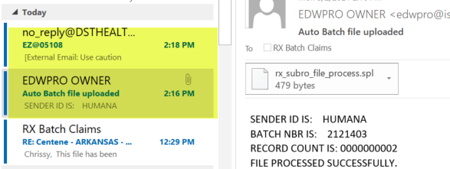  - Once the batches have been submitted, send a courtesy reply email to the original request for submission in the rxbatchclaims@humana.com inbox to let the agency know that the file has been submitted for processing.  - Update the ECT tracking database.  - Go to the following file location: \\Rsc.humad.com\qdrive\Pharmacy Other\Pharmacy COB\Batch Files\Tracking Database - ECT  - Open the MS Access database titled “ECT Tracking”  - From the main menu, click the “Batch Claim Entry Form” button.  - Enter the batch number.  - For the “Date File Received” box, enter the date the ECT subrogation batch file/s was received in the RX Batch Claims inbox.  - For the “Date File Sent to SS&C” box, enter the date the ECT subrogation batch file/s was sent for processing.  - Pick the name of the agency under the “Agency Name” drop-down box.  - Take a count of the volume of claims on the ECT subrogation batch file and enter that number in the “Volume of Claims Received” box.  - NOTE: the batch number and claims counts can all easily be found in the SECOND email received.  - Move all emails to Agency Folder in Shared Mailbox (categorize each email with corresponding color category)  - Move text batch files and spreadsheets (member and batches) in Shared Drive to Agency folder.  - Once the batch is processed by SSS&C, the results will be NDM’d to Humana (within 1-3 business days) from SS&C Three text files will be placed into the following folder: \\Rsc.humad.com\qdrive\Pharmacy Other\Pharmacy COB\Batch Files\Batch Responses. One file will contain a summary of the paid and denied claims from that batch. The other two will contain claim detail for both the paid and denied separately and will be labeled as such. These usually arrive within a day or two of the batch being submitted.  - When these are received, access the ECT Tracking Database in step j, find the appropriate entry in the “Tracking Table” table, and insert the date the response file were received in the “SS&C Response Date” column.  - Email the response files to the appropriate agency – usually it is easiest to reply to the original submission request email.  - If the batch responses are not received within 3 business days, email Humana (Humana@dsthealth.com) and cc: CPO Subrogation GPOMedicareMedicaid@dsthealth.com and Winkel, Rod C RCWinkel@dsthealth.com  - In the subject line, add “Missing batch response reports.” In the body, the same as subject line and provide the batch number.  - Subrogation Batch B2 Reversals  B2 Batch Reversals are needed when a batch is processed incorrectly the first time. The batch can be reprocessed as a B2 reversal and the batch (claims) would be reversed. Once the reversals have been validated through the response files as processed the batch can be reprocessed again with correct criteria. Here are some examples below for when a B2 reversal would be appropriate.  - Batch is processed with incorrect Agency ID  - Batch was processed with one member that has a primary OI on file. But, the member should not have had a primary on file.  The B2 submissions should be done the same way as outlined in the document above. Except for a few added steps to the Database portion.  - Open the Change or Rawlings Database (Both have been updated for B2 Reversals)  - Click Delete Old Data button.  - Import the file again that was submitted incorrectly the first time and save to Batch File folder.  - Update Raw Data  - Click to update NPI  - Run the B2 update query  - Click export final results- B2 Reversals macro - txt file will load to Change or Rawlings folder on Q drive.  - Follow steps in above document starting with below steps and so on.  - Save a copy (move) of the formatted batch text file in a folder you create either on your desktop or your my documents folder on your local drive.  i. Rename the files by their batch ID
  Member ID Number | Customer 319 |  | Customer 320 and 544
  Member ID Number | Vendor Code | Sender ID | Vendor Code | Sender ID
  Member ID/SSN | 21 | HUMANA | 22 | HUMANA

Revision History
Date | Revision Description | Author
4/28/2014 | Original Document | Adam Burns
1/6/2019 | Revision/Updates | Lee Warner
1/21/2020 | Major Revisions & Reformatting | Lee Warner
2/17/2022 | Updates | Wendy Williams
05/12/2022 | Added run query in RX Intel for N/A customer #, replaced Argus with SS&C | Kristy Gonczeruk
06/15/2022 | Updated CPO Subrogation email address | Kristy Gonczeruk
07/15/2022 | Added name character length | Kristy Gonczeruk

